Date: 13/08/25

Lab Practical #07:
Study the application layer protocol DNS, DHCP, FTP. Practical Assignment #07:
- Implement the application layer protocol DNS, DHCP, and FTP. Also check connectivity between them using ping command or PDU utility.
Instructions:
  - Protocol-wise configuration setup screenshot.
  - Mention IP address of each pc as label.
  - Ping command or PDU screenshot between two pcs.

- DNS:

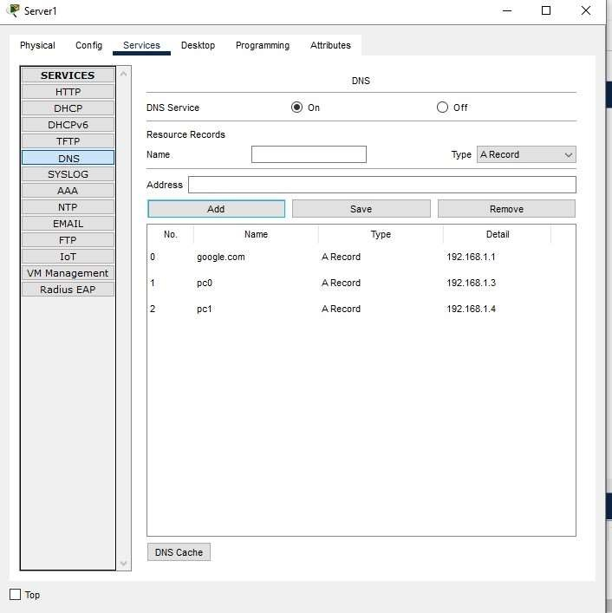

Date: 13/08/25
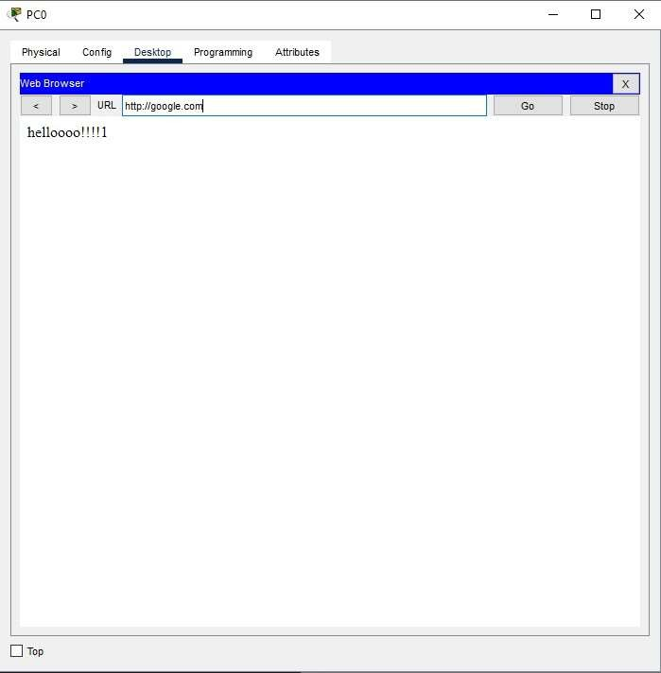

Date: 13/08/25
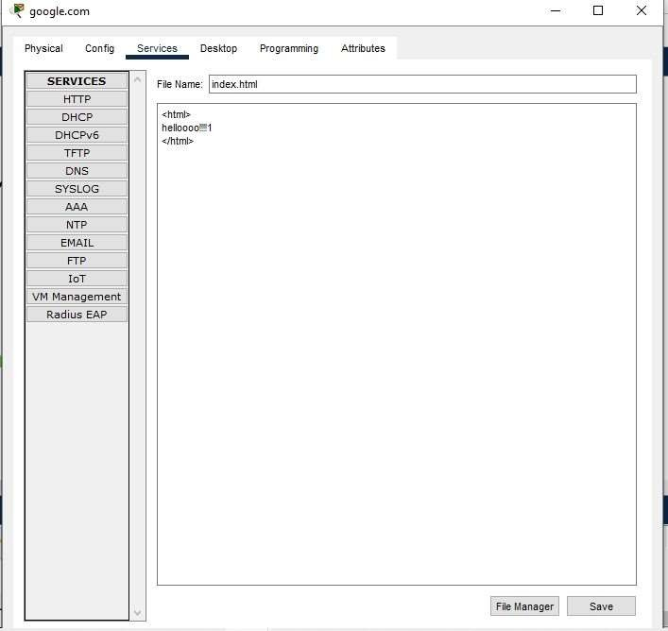

Date: 13/08/25

- DHCP:
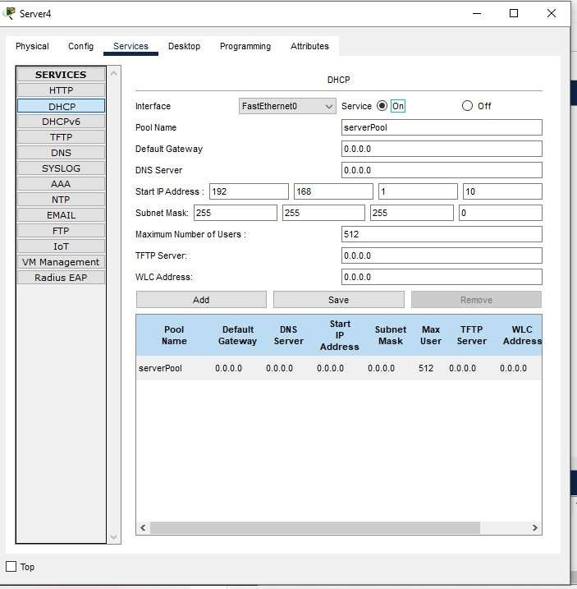

Date: 13/08/25
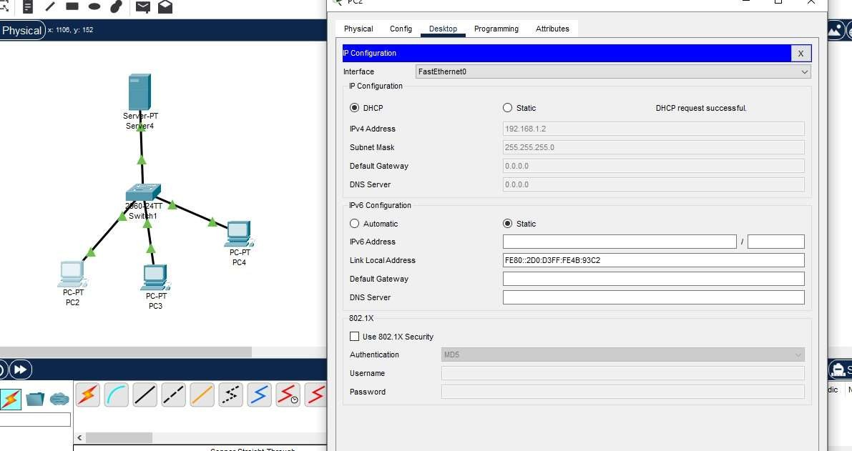

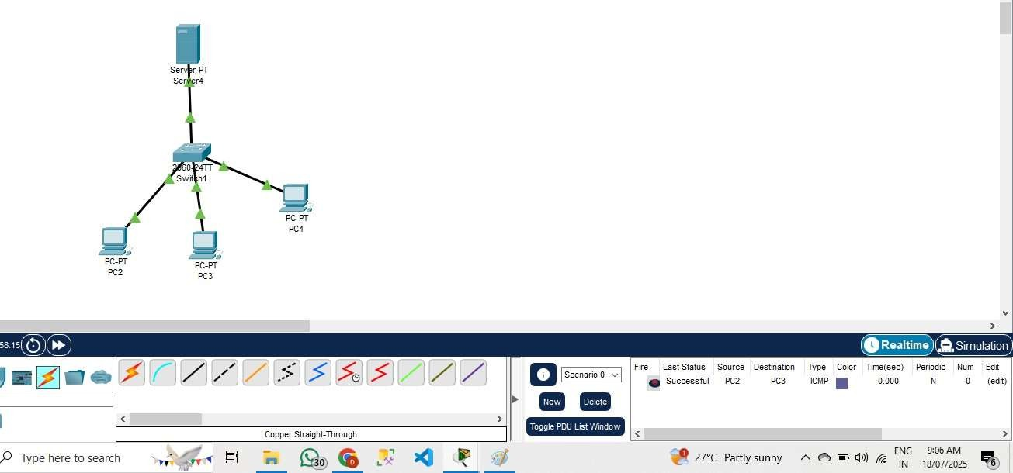

- FTP:

Date: 13/08/25
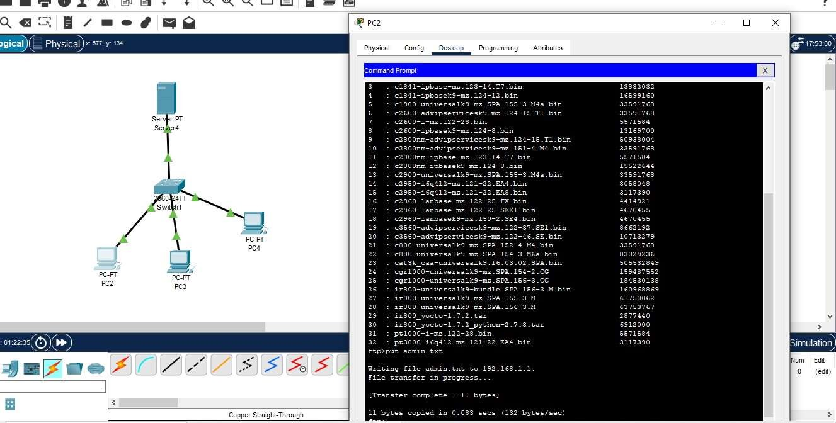

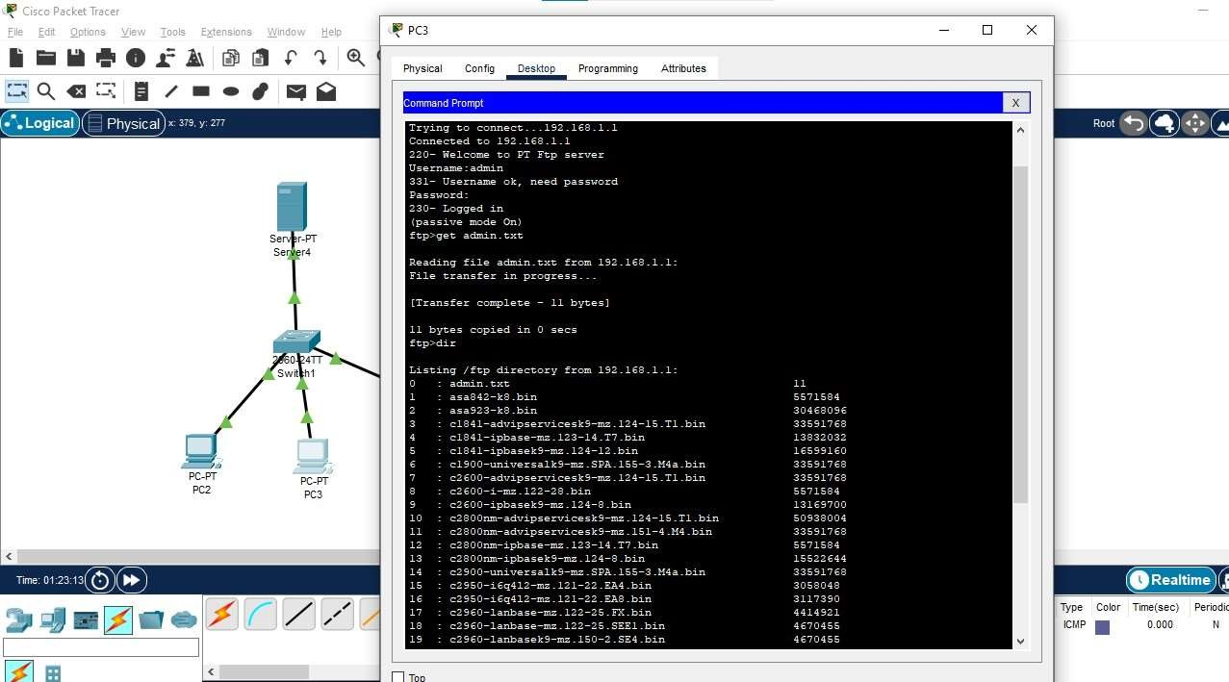

Date: 13/08/25
